**FUNCTIONAL REQUIREMENT DOCUMENT FOR DISPLAY BOOKSHELVES**

[**https://www.urbanladder.com**](https://www.urbanladder.com)

**Submitted By**

**KINESTHETICS**

SRAVYA KATUKURI

SAILAJA KANDLURI

NACHIKET KISAN SHEJWAL

MOHAMMAD KHALEED DUDEKULA

912790

912797

912649

912786

**CONTENTS**

1. INTRODUCTION
   1. Purpose 3
   2. Intended Audience 3
2. DESCRIPTION 3
3. FUNCTIONAL REQUIREMENTS
   1. Home Page 4
   2. Search 5
   3. Search Results 6
   4. Collections menu 10
   5. Gift Cards 13
4. **INTRODUCTION**

The functional requirement document is a complete description of the new feature of the urbanladder.com website. This document also describes the user interaction and the response of the webpage.

* 1. PURPOSE

The purpose of the document is to give the functional requirements for the ‘Display Bookshelves’ in **urbanladder** website. This document will help the audience to understand the behaviour of the application for development.

* 1. INTENDED AUDIENCE
* Business Unit (BU) Person
* Academy Coach
* Technical Trainer
* Project Team

1. **DESCRIPTION**

Urbanladder.com is an online furniture shop. It has different types of furniture set like Book Shelves, Study Chairs, Study Tables, Beds, Dining etc. It also provides detailed description of the products like price, features and material type.

1. **FUNCTIONAL REQUIREMENTS**

When you type the URL <https://www.urbanladder.com/> it should navigate by default, to Homepage without showing any Advertisement.

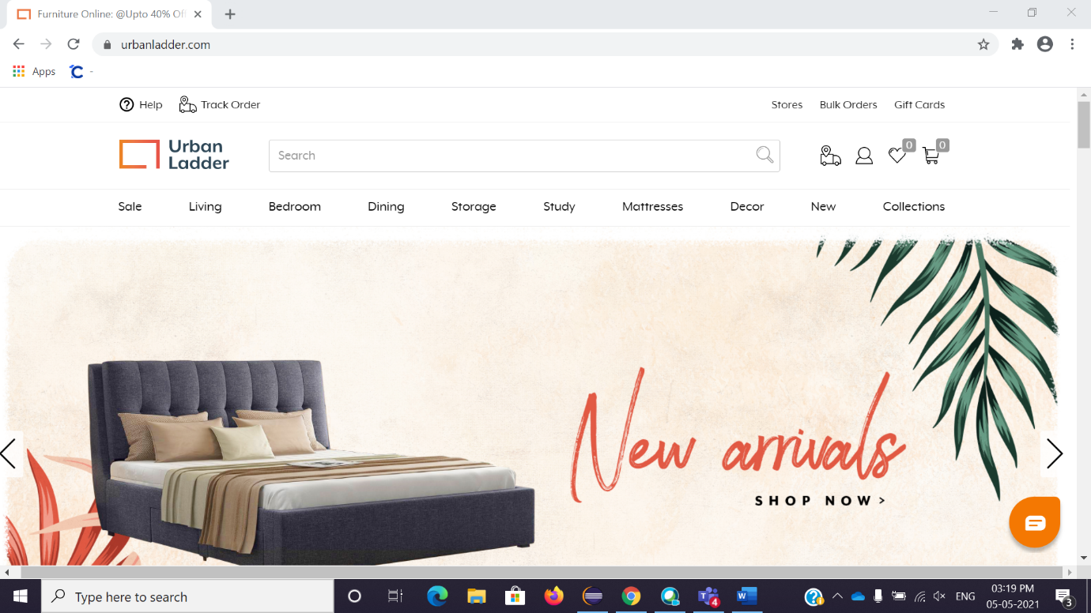

Fig. Homepage

* 1. **Home page:**

When user is on Homepage the Homepage should contain the following fields.

* Menu bar which includes the following fields:
* Sale
* Living
* Bedroom
* Dining
* Storage
* Study
* Mattresses
* Décor
* New
* Collections
* Textbox is locating at top side middle position in the Rectangular shape.
* Search Button is located in the Textbox itself at right corner side having symbol of Magnifying glass.
* Recommendation Slider should be located at middle of page as we scroll down the page, we can see the product is sliding to left with time interval of 2 second.
* Urban Ladder Logo should be place at left top corner of page & above the menu bar, refer the fig.
* At the right side of textbox multiple options **like Track order, Log in & Sign Up, wish list & My Card** must appear.
* Moving on the bottom side there is Orange coloured Symbol at right bottom corner is placed for any Help regarding Product or Technical issue.

**3.2 Search:**

* The textbox **Search** is needed to type name of product user want & if user type something it will show the matching alphabetical list in drop down.
* Enter the **Bookshelves** & click on **Search Button which** is located at right side of Textbox.
* This will show the Bookshelves Page.

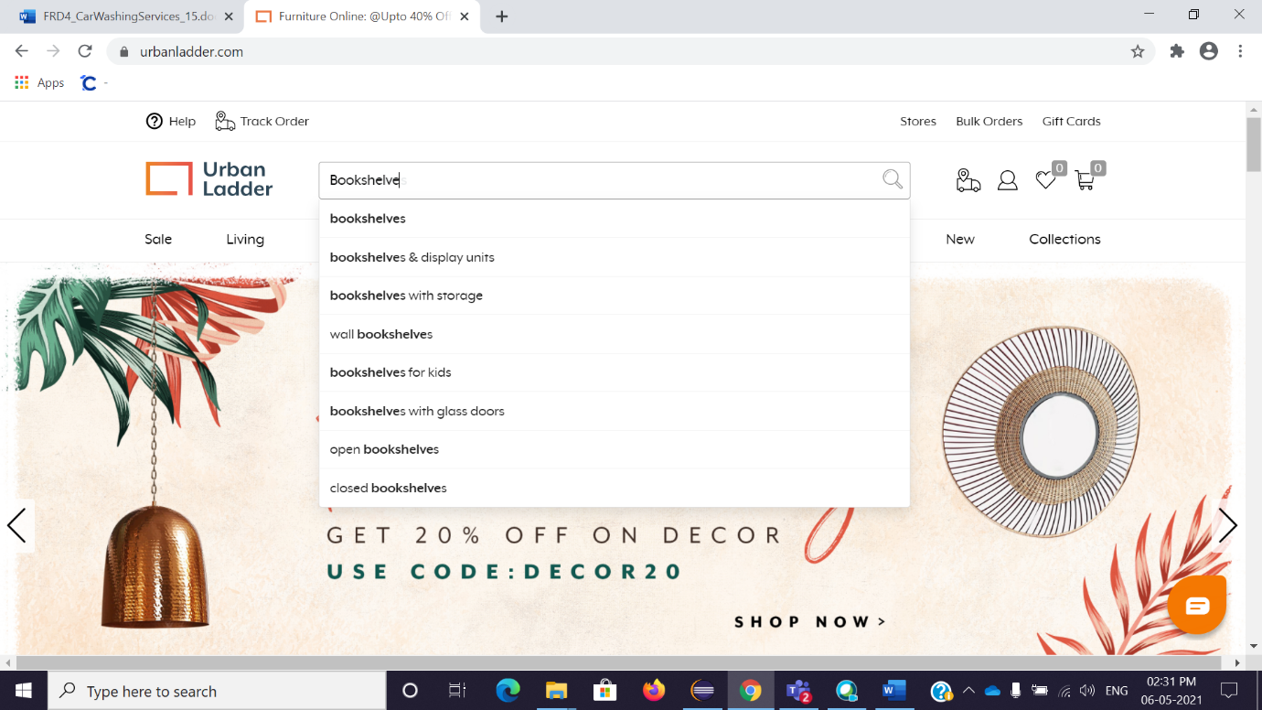

Fig. Search drop down list

* The user will able to choose from drop down list as well as directly search the Product name, e.g., Type the Bookshelves in Textbox & click on search Button in the textbox, this will populate the results by default using Sort filter.

**3.3 Search Results:**

* The search results page will populate number of Product list according to recommendation by default & the different filter as,
* Category
* Price
* Storage Type
* Type
* Material Finish
* On the Right side, the page would show check box for **Exclude out of stock &** sort by drop down list from user can select,
* Recommended
* Price: Low to High
* Price: High to low
* New Arrival

Any one of them.

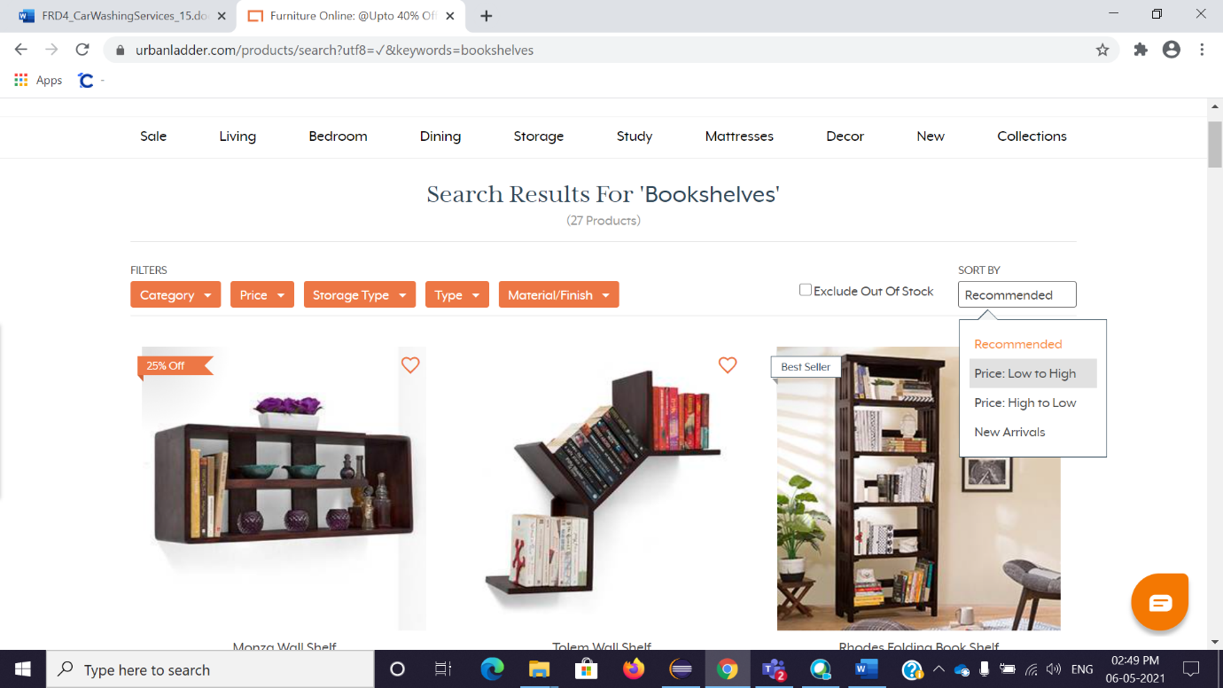

**Fig. Sort by drop down list**

* Moving on to the filters, in the first the user should see the drop-down list when user move the Cursor on **Category Button** as having the check box & category name as,
* 1.Bookshelve
* 2.Display cabinets
* 3.Wall Shelves
* 4.Crockery Units
* The user can Tick on single check box as well multiple also.

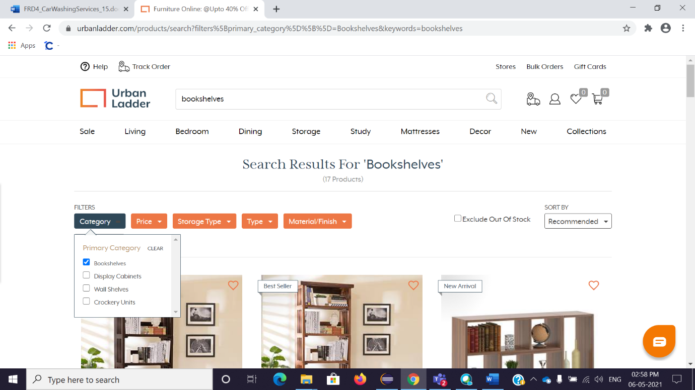

**Fig. Category Drop down list**

* Moving on to next filter **Price** when user move the Cursor on price Button which is Orange in colour it should generate rectangular window having price range and 4 radio Buttons as,
* Rs. 899 to Rs. 4999
* Rs. 4500 to Rs. 8999
* Rs. 9000 to Rs. 15999
* Rs. 16000 to Rs. 41399
* The user can only choose single Button or can limit the price range using price slider having the minimum value Rs. 899 & maximum value Rs. 41399.

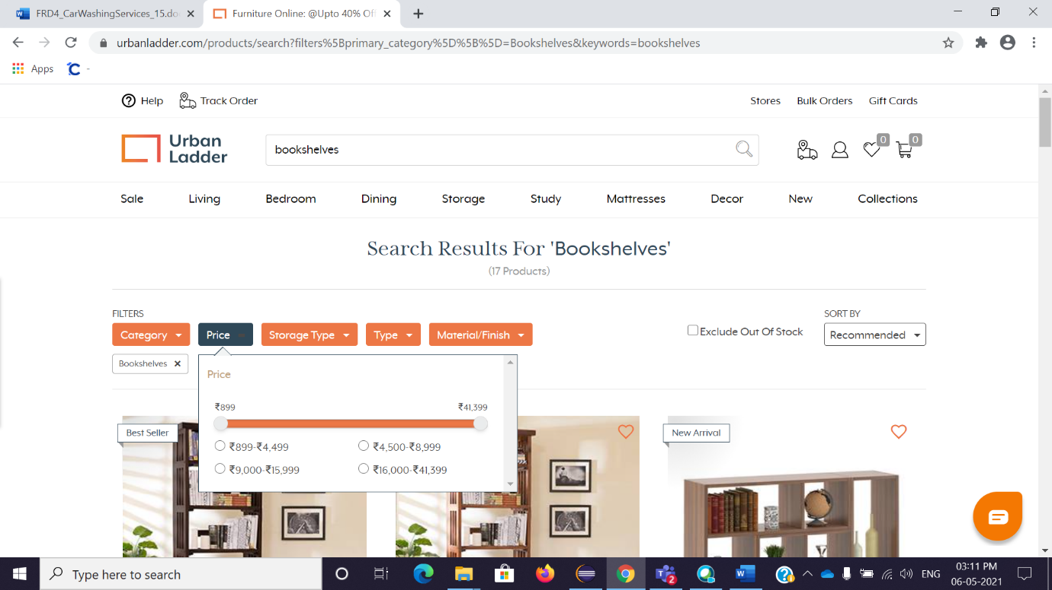

**Fig. Price filter window**

* Storage Type filter give the choices to Customer that he/she can choose the type of storage of product as,
* Open
* Closed
* Open Storage
* Open & Closed
* The user should be able to choose single as well as multiple check box, e.g. Select Open type after selecting filters user can see the selected filters at just below the filters Button.

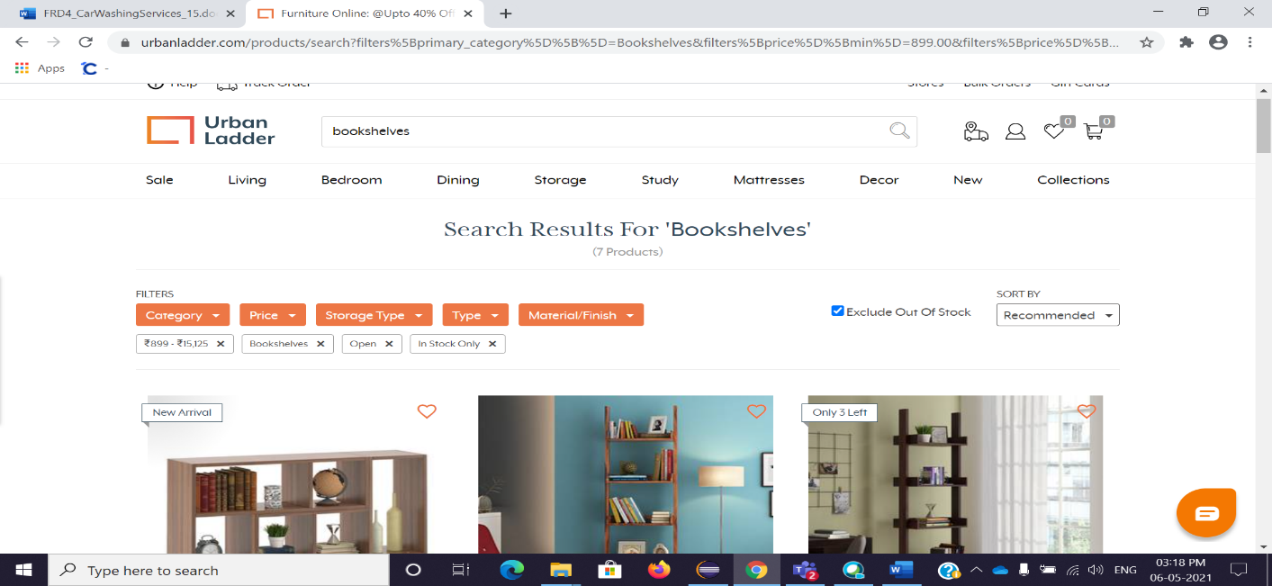

**Fig. Filters**

* On the right there is one Check box **Excluded out of stocks** which for showing the product not available for now, the user should be able to select it.
* After selecting the filters product according to filter should be display as 3 items in single row & so on. The result shows the image of product, Name, Capacity, Price & EMI range. If user move Cursor on product, it should show the **Add to Compare** & **View Button**.

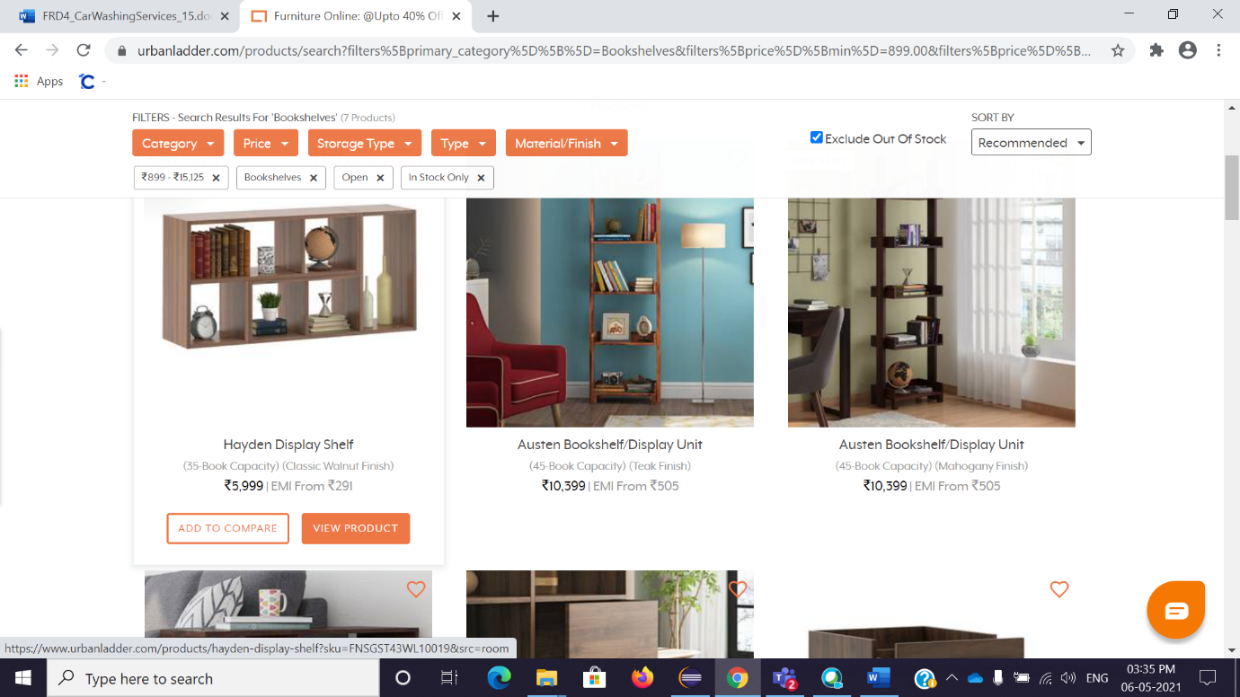

**Fig. results**

**3.4 Collections**

* Open [https://www.urbanladder.com](https://www.urbanladder.com/) website.
* Urban Ladder home page will be displayed.
* On right side ending there is an option of ‘Collection’ filter
* Click on ‘collections’

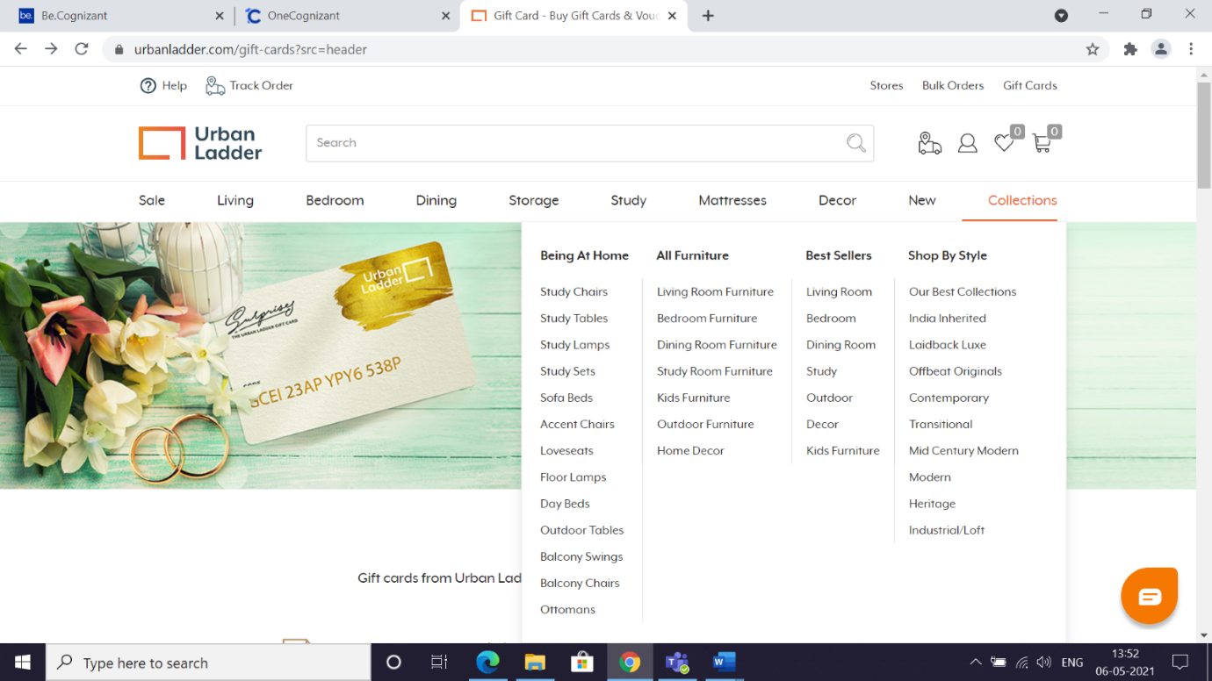

**Fig. Collection Menu**

* The box will be open and inside there are having FOUR options:
* Being at Home: working or studying from home as surprise for most of us, Below Furnitures are available to the Users who are Being at home
* Study Chairs
* Study Tables
* Study lamps
* Study Sets
* Sofa Beds
* Accent Chairs
* Loveseats
* Floor Lamps
* Day Beds
* Outdoor Tablets
* Balcony Swings
* Balcony Chairs
* Ottomans

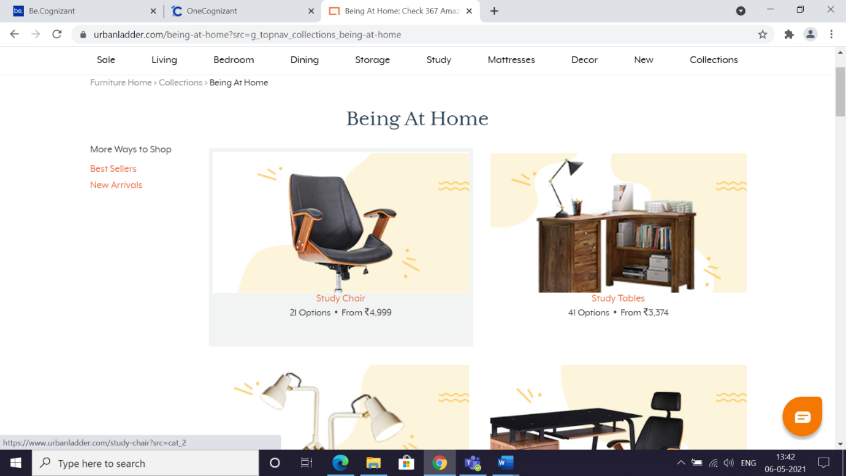

**Fig. Being at home category**

* All Furniture: it is a movable object. There are many reasons to buying an Furnitures, we need furniture for more comfortable lives and use it for storage, sitting on, and for sleeping. Below All type of Furnitures are available
* Living Room Furniture
* Bedroom Furniture
* Dining Room Furniture
* Study Room Furniture
* Kids Furniture
* Outdoor Furniture
* Home Decor

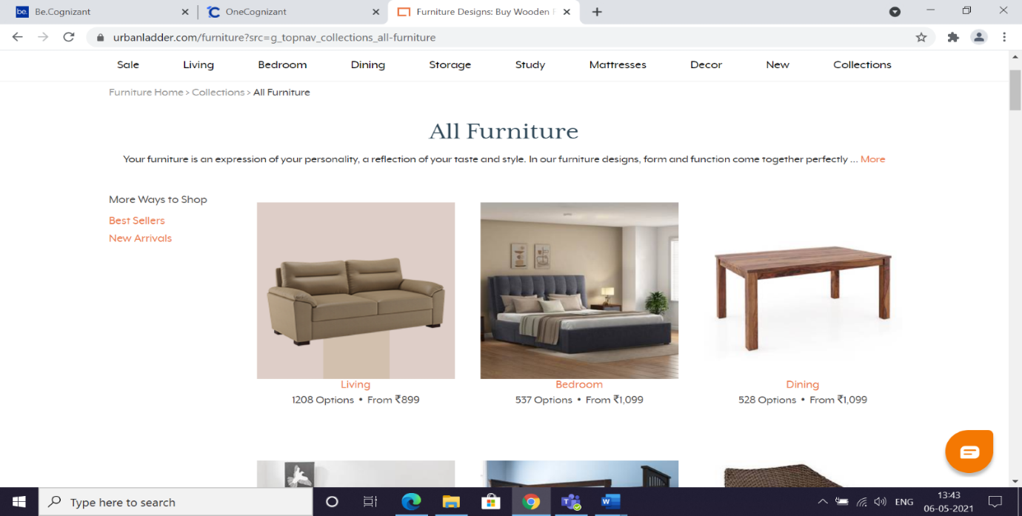

**Fig. All furniture Category**

* Best Sellers: Best sellers lists may vary widely depending on the method used for sales. Below   are the products that which people have bought highly
* Living Room
* Bedroom
* Dining Room
* Study
* Outdoor
* Decoder
* Kids Furniture

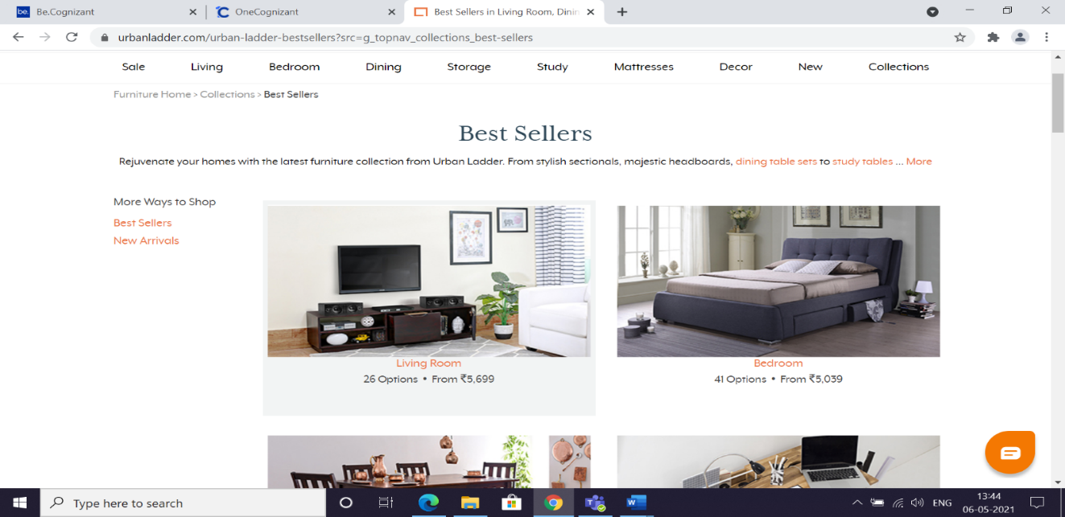

**Fig. Best seller**

* Shop by Style: choosing our personal style give us more satisfaction and comfort to us. Below are the details that which are our best styles
* Our Best Collections
* India Inherited
* Laidback Luxe
* Offbeat Originals
* Contemporary
* Transitional
* Mid Century Modern
* Modern
* Heritage
* Industrial/Loft

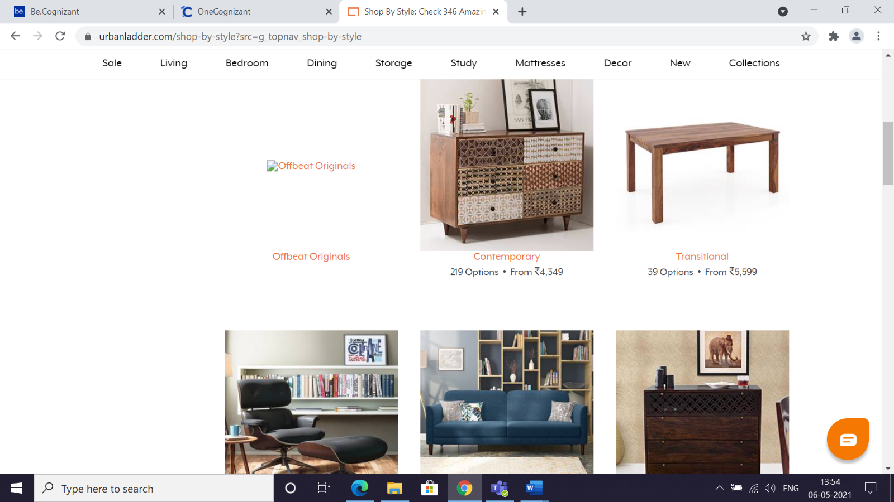

**3.5 Gift Card:**

* Open [https://www.urbanladder.com](https://www.urbanladder.com/) website.
* Urban Ladder home page will be displayed.
* On right side top   there is an option of ‘Gift card’
* While clicking on ‘gift card’ the page will display

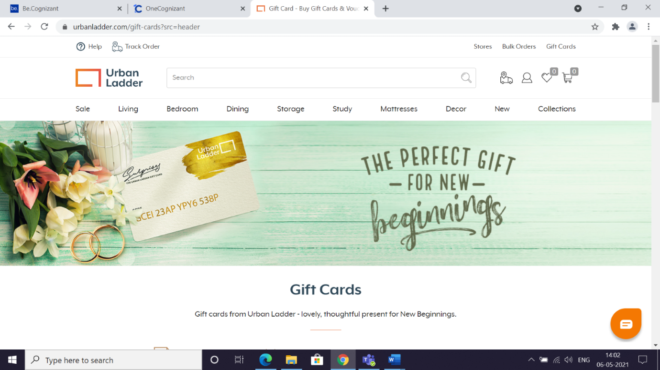

Home page

* When the page is scrolled down:

1. There are six occasions
2. It shows **1. First,** **choose an occasion**
3. Choose an occasion as **Birthday/Anniversary**

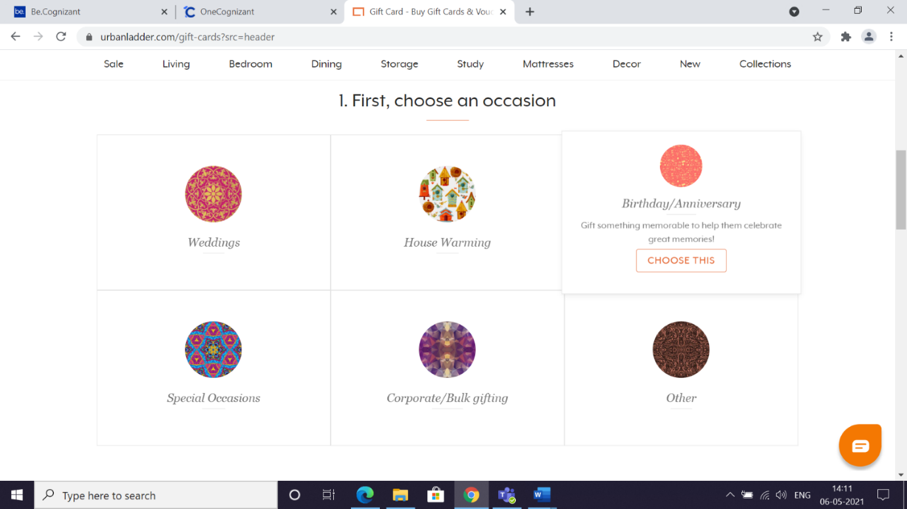

**Fig. Gift card**

* Now page 2 will display
* It shows that:  Now customise your gift card. There is having three boxes of an amount(rupees)such as: 1000, 5000, 10000**,** select an any one option of an amount**.**
* Select Enter the amount in between 1000 and 5,00,000
* Enter the amount in the box
* Select on send on:

There are having two boxes

* Month
* Date
* Click on drop down month box
* It showing three months such as May (2021), June (2021), July (2021),
* Select one month among them
* Next click on Date box (dropdown)
* Select a date
* Fill all the details in the page

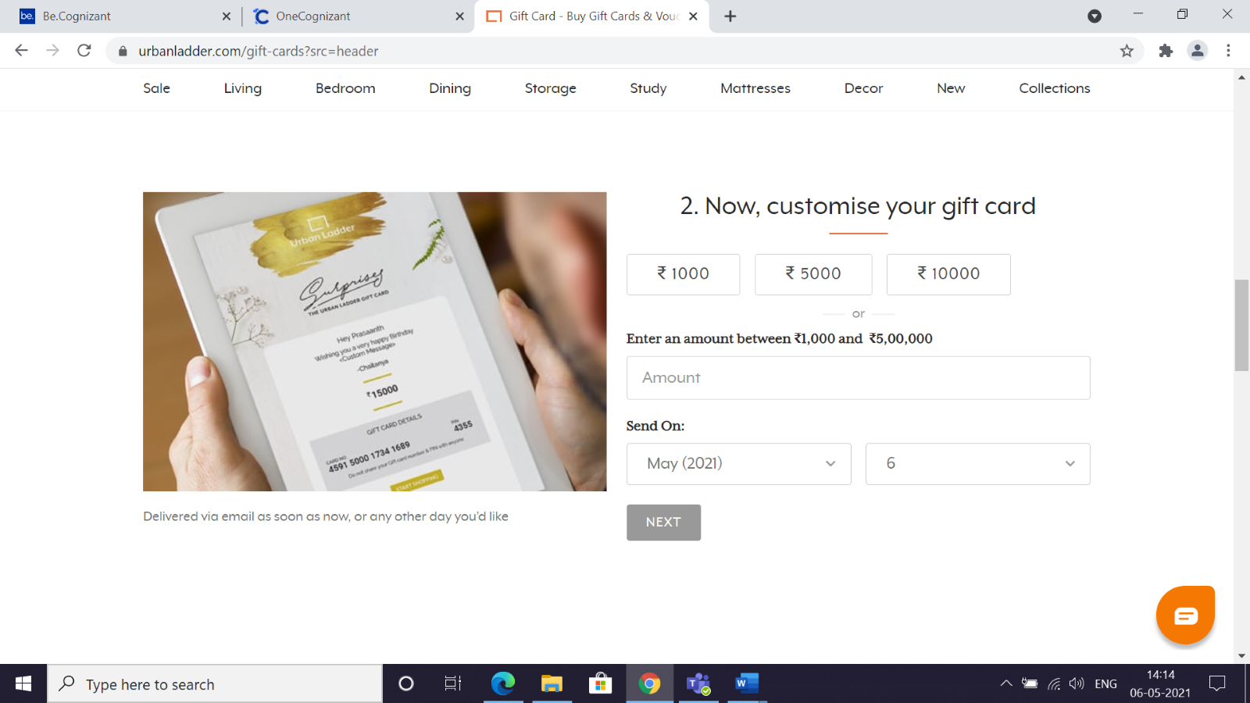

**Customise gift card**

* Click on Next option:Page 3 will display.**E**nter the details in To,
* Recipient’s name
* Recipient’s email
* Enter the valid details in the boxesSo, enter the details in formIt having three boxes:
* Your name
* Your email
* Your mobile
* Enter the valid details in the boxes

* There is having message box which is optional
  + - If we want to write any message here, then
* Click on the box and enter the message in 200 characters
* Click on conform button for submit process

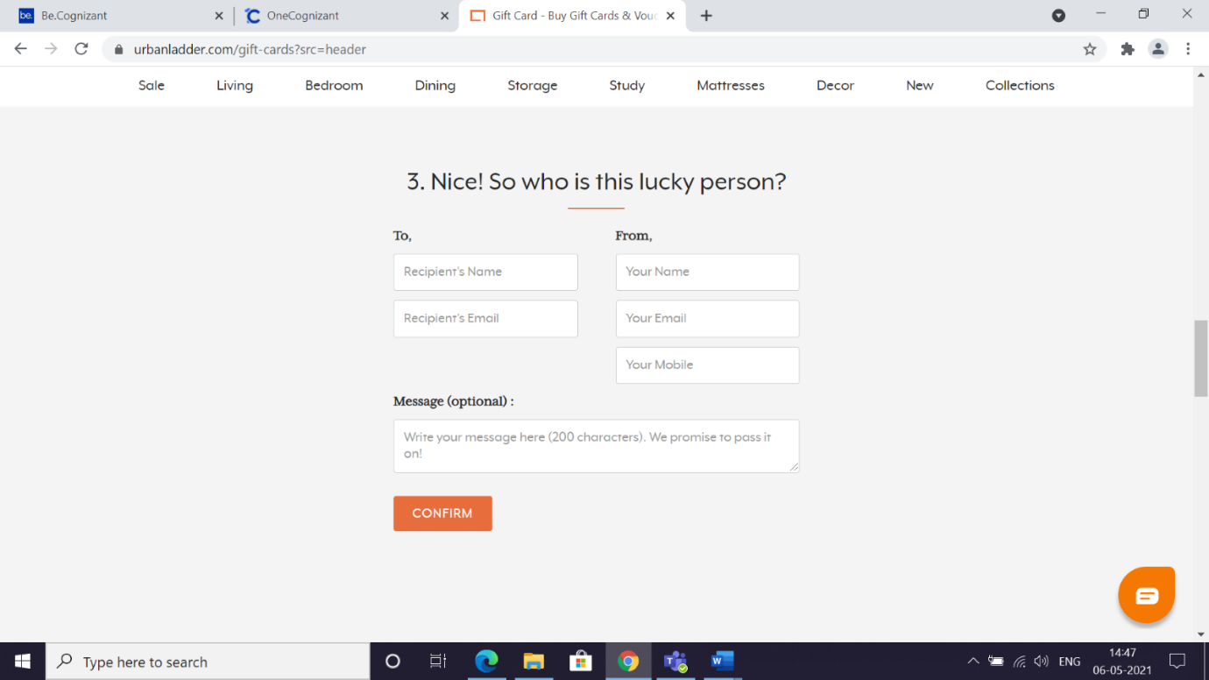

**Fig. Submit**